Java lab questions and answers
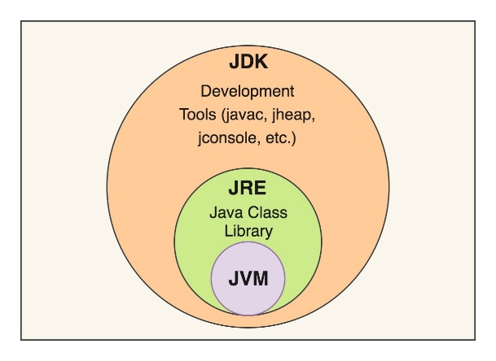
1. Explain the main concept used in Java environment setup, variables, and methods.
- Java Environment Setup: It prepares the computer to develop and run Java programs using JDK, JRE, and JVM.
  - JDK: Used to write and compile Java programs.
  - JRE: Provides the environment to run Java programs.
  - JVM: Executes the Java bytecode.
- Variables: Variables are named memory locations used to store data such as numbers or text.
- Methods: Methods are blocks of code that perform a specific task and can be reused multiple times.

2. What are the advantages of using Java variables and methods?
- Variables:
  - Store data.
  - Easy to update values.
  - Make the code easier to understand.
- Methods:
  - Reuse code without rewriting it.
  - Reduce duplicate code.
  - Make programs organized and easy to maintain.

4. What are the real-world applications?
Java is used in:
- Banking systems (online banking, ATMs)
- Web applications (shopping and college websites)
- Android app development
- Desktop applications
- Enterprise software (employee and payroll systems)

